G.K -class-2

1. Write action words. 4Marks
2. Write the words in blank spaces. 8Marks

1.Group of photographs in a book ___________

2. Group of coaches /wagons _____________

3. Group of eggs _____________

4. Group of flowers ________________

5. Group of keys ______________

6. Group of drawers _____________

7. Group of flats ______________

8. Group of books ____________

III. Match the following. 3Marks

Nation Nationality

1.The United states a) French

2.The United Kingdom b) Japanese

3) Japan c) Chinese

4) Bangladesh d) English

5) China e) American

6) France f) Bangladeshi

IV. Write name of five sense organs. 5Marks

V. Write the name of the computer parts. 5Marks

1. 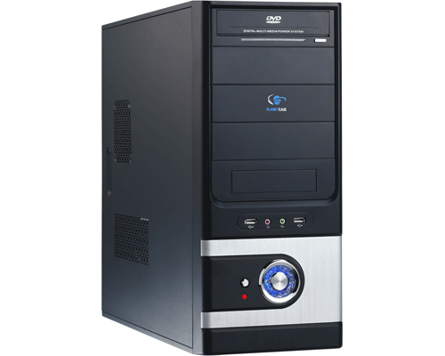 2. 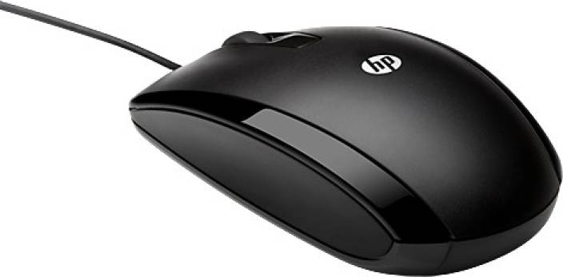 3. 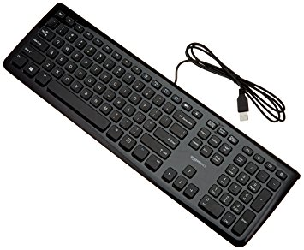

4.  5. 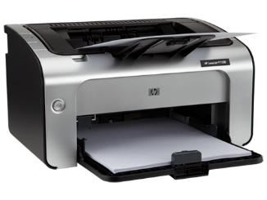

VI. Write the correct name of the tool in the blank space. 7X ½ M=3 ½ M

|  |
| --- |
| Broom  Axe , scissors  Thermometer  Chalk  balance, saw |

1. I use a ___________ to weigh things.
2. I use an __________ to cut wood.
3. I use a ___________ to take your temperature.
4. I use a ___________ to write on the black board.
5. I use a ___________ to cut cloth.
6. I use a ___________ to sweep the road.
7. I use a ___________ to cut wood and make furniture.

VII. Write name of the activity. 6Marks

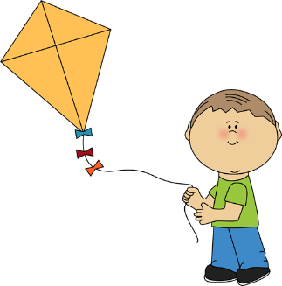 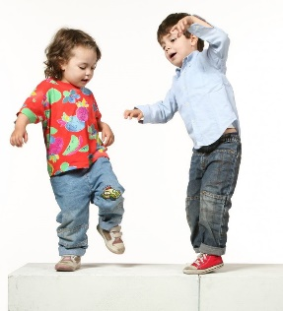 

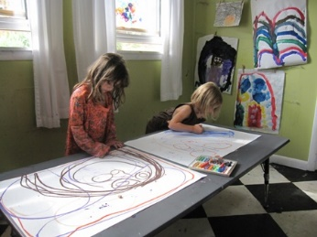 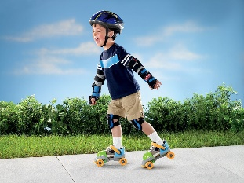 

VIII. 4Marks

1. Which is the capital of India?
2. Which time was shifted capital from Calcutta to Delhi?
3. This is the last fort built in India and it is situated in old Delhi.
4. Who is known as the father of computers?

IX. Draw a pond picture 1 ½ Marks